PROBLEM SOLUTION - FIT

1. **CUSTOMER SEGMENT(S)**

* Sundowner

.

.

.

* FamilyFarms
* Commercial Operators
* Large Scale Operations

**2.CUSTOMER CONSTRAINTS**

* Lack of proper irrigation facilities
* Production machinery
* Access to institutional credit
* Difficulties in procuring inputs and storing products
* Negative impacts of climate

**3.TRIGGERS**

* Real time weather forecast
* Pumping systems
* Irrigation methods
* Fertilizers
* Irrigation efficiency

**4.JOBS TO-BE-DONE / PROBLEMS**

* Often there occurs problems in finding the amount of water content ,nutrient content in the soil (less nutrient content leads to nutrient deficiency),in sensing the variation in intensity of sunlight and in measuring the amount of chemical in the soil properly.
* To avoid these problems,soil moisture sensor,NPK sensor,LDR sensor and electrochemical sensor were to be used to solve the above respective problems

**5.ROOT CAUSE**

The root cause for these mentioned problems might be the intensive groundwater pumping for irrigation,using more fertilizers,surface runoff from farfields,faster growth of algae etc…

**6.BEHAVIOUR**

# For improving the production, land reforms are

# the first and predominant point.

# Plant more densely

# Smart water management

# We must improve the heat-tolerant varieties,so that it increases the crop yield by up to 23%

# improved seeds are best to enhance farm productivity

This PDF document was edited with **Icecream PDF Editor**.

**Upgrade to PRO** to remove watermark.

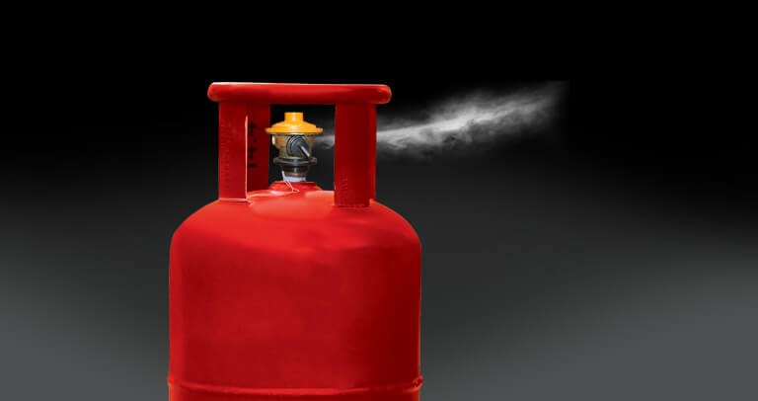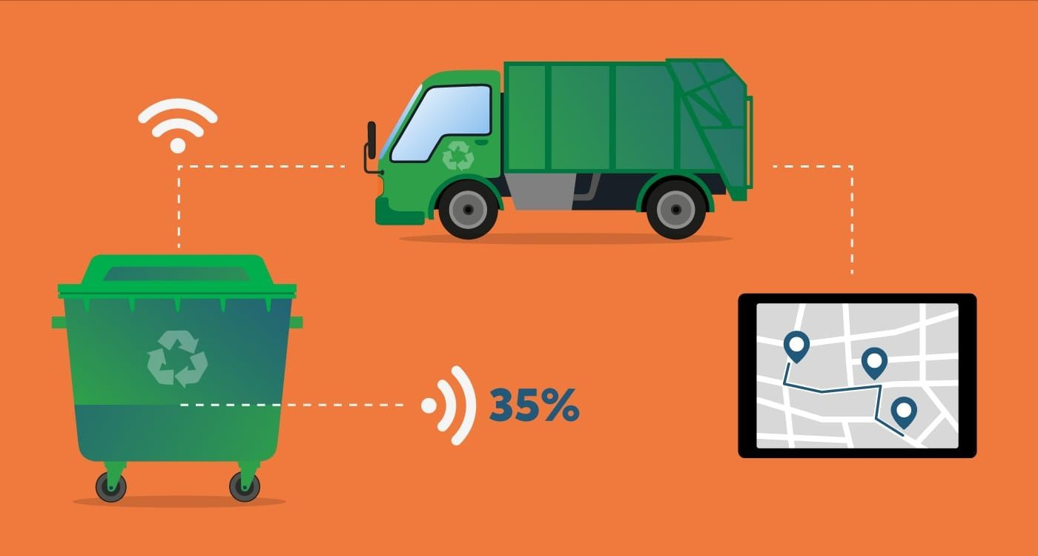

**7.SOLUTION**

* By calculating the amount of water content,nutrient and electro chemical content accurately with the help of the above mentioned sensors.
* right time.
* Harvesting at right time and marketing for good price.